NAME: MOHAMMED AFNAAN AHMED
TITLE: types of hackers and attackers and protocol and ports
Information Taken: google and other websites
Content:
A Hacker is a person who is intensely interested in the mysterious workings of any computer operating system. Hackers are most often programmers. They gather advanced knowledge of operating systems and programming languages and discover loopholes within systems and the reasons for such loopholes. In this article, we will learn about all types of hackers, the Difference between White, black and, grey hat hackers, ways to protect against them.
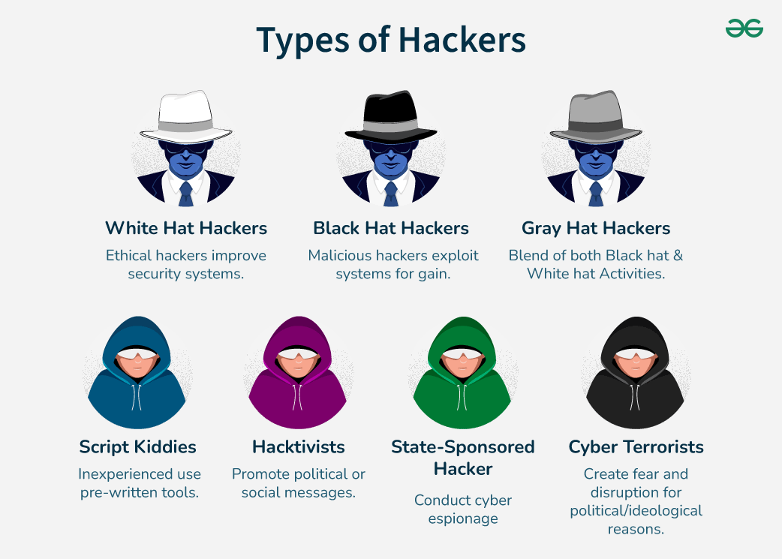
White Hat Hackers
White Hat hackers are also known as Ethical Hackers. They never intent to harm a system, rather they try to find out weaknesses in a computer or a network system as a part of penetration testing and vulnerability assessments.
Ethical hacking is not illegal and it is one of the demanding jobs available in the IT industry. There are numerous companies that hire ethical hackers for penetration testing and vulnerability assessments.
Black Hat Hackers
Black Hat hackers, also known as crackers, are those who hack in order to gain unauthorized access to a system and harm its operations or steal sensitive information.
Black Hat hacking is always illegal because of its bad intent which includes stealing corporate data, violating privacy, damaging the system, blocking network communication, etc.
Grey Hat Hackers
Grey hat hackers are a blend of both black hat and white hat hackers. They act without malicious intent but for their fun, they exploit a security weakness in a computer system or network without the owners permission or knowledge.
Their intent is to bring the weakness to the attention of the owners and getting appreciation or a little bounty from the owners.

Miscellaneous Hackers
Apart from the above well-known classes of hackers, we have the following categories of hackers based on what they hack and how they do it −
Red Hat Hackers
Red hat hackers are again a blend of both black hat and white hat hackers. They are usually on the level of hacking government agencies, top-secret information hubs, and generally anything that falls under the category of sensitive information.
Blue Hat Hackers
A blue hat hacker is someone outside computer security consulting firms who is used to bug-test a system prior to its launch. They look for loopholes that can be exploited and try to close these gaps. Microsoft also uses the term BlueHat to represent a series of security briefing events.
Elite Hackers
This is a social status among hackers, which is used to describe the most skilled. Newly discovered exploits will circulate among these hackers.
Script Kiddie
A script kiddie is a non-expert who breaks into computer systems by using pre-packaged automated tools written by others, usually with little understanding of the underlying concept, hence the term Kiddie.
Neophyte
A neophyte, "n00b", or "newbie" or "Green Hat Hacker" is someone who is new to hacking or phreaking and has almost no knowledge or experience of the workings of technology and hacking.
Hacktivist
A hacktivist is a hacker who utilizes technology to announce a social, ideological, religious, or political message. In general, most hacktivism involves website defacement or denialof-service attacks.
Ways to Protect Against Hackers
Protecting against hackers involves implementing various cybersecurity measures to safeguard your data and systems.
- Regularly updating software and operating systems ensures that security patches are applied to fix vulnerabilities.
- Using strong, unique passwords for different accounts and enabling two-factor authentication adds an extra layer of security.
- Installing and maintaining reliable antivirus software helps detect and remove malware.
- Educating employees and users about phishing and social engineering tactics can prevent successful attacks.
- Additionally, securing networks with firewalls and encryption protects sensitive information from unauthorized access.
A cyberattack is a conscious endeavor by people or gatherings to break or think twice about frameworks, organizations, or gadgets to disturb tasks, take information, or cause harm. These assaults can take different forms, including malware, phishing, ransomware, or forswearing administration (DoS) assaults. Cyberattacks target weaknesses in programming or equipment, expecting to take advantage of these shortcomings for malevolent purposes. They can prompt critical monetary misfortunes, information breaks, and functional disturbances. Safeguarding against cyberattacks includes carrying out vigorous safety efforts, customary updates, and client instruction to defend delicate data and keep up with framework trustworthiness.
Some basic Cyber attacks are:
1. Phishing: Phishing is a fraudulent action of sending spam emails by imitating a legitimate source. At its center, phishing abuses human motivations through alluring message or offer. Aggressors as a thumb of rule resort to phishing assaults by focusing on huge gatherings and subsequently increase the odds of probably few targets succumbing to assault. A commonplace case of phishing assault includes aggressor mimicking individual or foundation and sends messages to clueless targets requesting prompt assistance with connection appended to correspondence. Unaware client taps on connection, which takes them to phony site that appears to be like real site. Individual, uninformed of snare, falls into it and winds up offering individual subtleties to aggressor, who at that point ransacks client even before they understand that they have been assaulted.
2. Social Engineering Attacks
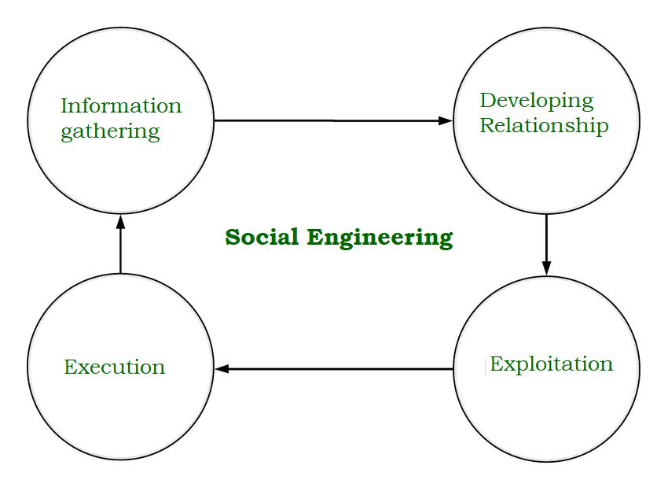
Social engineering is now common tactics used by cybercriminals to gather user’s sensitive information.
Social engineering assaults come in wide range of structures and can be performed in any place where human collaboration is included. Coming up next are five most basic types of advanced social engineering attacks. Social engineering assaults occur in at least one stage. A culprit initially researches proposed casualty to accumulate fundamental foundation data, for example, likely purposes of passage and feeble security conventions, expected to continue with assault. At that point, assailant moves to pick up casualty's trust and give upgrades to resulting activities that break security rehearses, for example, uncovering sensitive data or allowing admittance to basic assets. Most berated type of bedeviling utilizes physical media to scatter malware. For instance, aggressors leave trap—regularly malware-tainted glimmer drives—in prominent territories where potential casualties are sure to see them (e.g., restrooms, lifts, the parking garage of a focused on organization). Snare has credible look to it, for example, name introducing it as organization's finance list.
3. Ransomware: Ransomware is a document encryption programming program that utilizes a special encryption calculation to scramble records on objective framework. It is particular malware disseminated to blackmail cash from targets and is one of most pervasive and known instances of cyber attacks. Assailant disseminates malware as infection to get to objective PC's hard drive. It, at that point, encodes information and makes PC/information unusable for client until they make the payoff installment requested by assailant. It is frequently difficult to decode record's substance without anyone else. WannaCry and Maze ransomware are ongoing instances of how malware could unleash devastation, driving numerous enterprises to dish out bitcoins and cash to pay for recovering their undermined machines and information.
4. Cryptocurrency Hijacking: As digital currency and mining are becoming popular, also it is among cyber criminals. They have found their evil benefit to crypto-currency mining which involves complex computing to mine virtual currency like Bitcoin, Ethereum, Monero, Litecoin so on.
Hackers have two primary ways to get victim’s computer to secretly mine cryptocurrencies. One is to trick victims into loading crypto mining code onto their computers. This is done through phishing-like tactics: Victims receive legitimate-looking email that encourages them to click on link. Link runs code that places crypto mining script on the computer. Script then runs in background as the victim works.
The other method is to inject script on website or ad that is delivered to multiple websites. Once victims visit website or infected ad pops up in their browsers, script automatically executes. No code is stored on the victims’ computers. Whichever method is used, code runs complex mathematical problems on victims’ computers and sends results to server that hacker controls.
Hackers often will use both methods to maximize their return. “Attacks use old malware tricks to deliver more reliable and persistent software [to the victims’ computers] as fallback, ” says Alex Vaystikh, CTO and cofounder of SecBI. For example, of 100 devices mining cryptocurrencies for hacker, 10% might be generating income from code on the victims’ machines, while 90% do so through their web browsers.
Some crypto mining scripts have worming capabilities that allow them to infect other devices and servers on network. It also makes it harder to find and remove; maintaining persistence on network is in the cryptojacker's best financial interest.
5. Botnets Attacks:
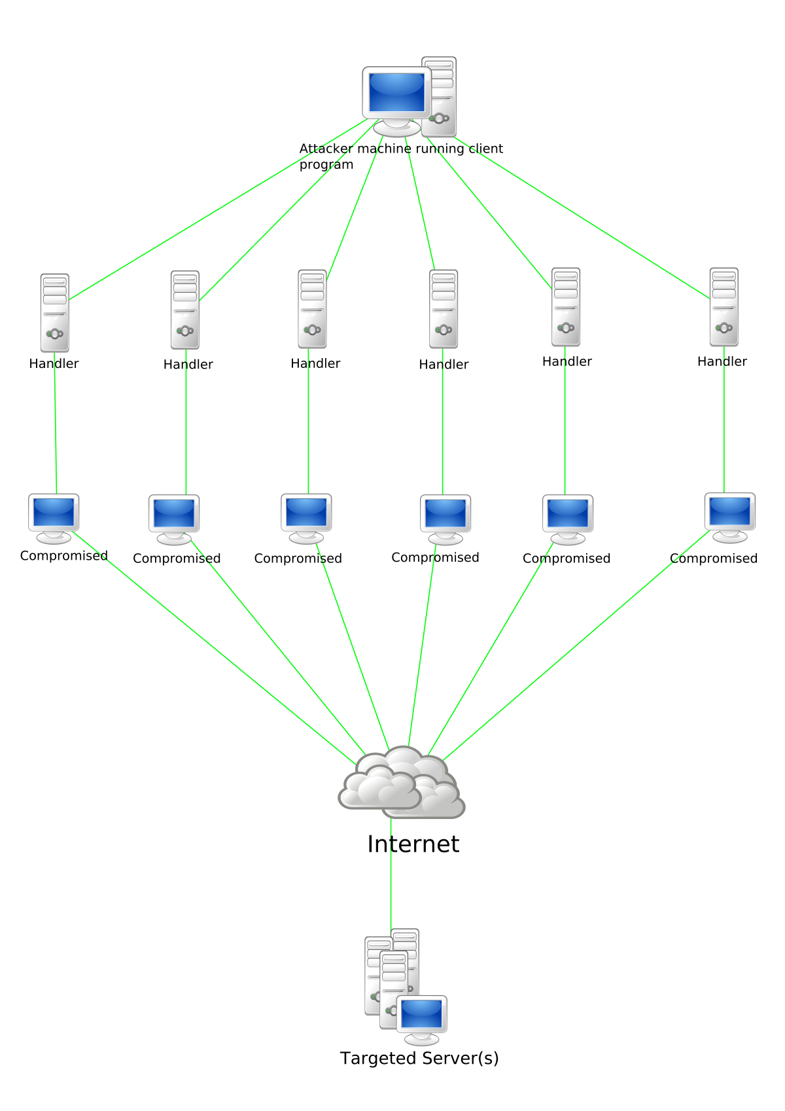
Botnets assaults are commonly targeted against huge-scope organizations and associations because of the immense information get to. Through this assault, the programmers can control countless gadgets and bargain them for their shrewd intentions.
Botnet proprietors can approach few thousand PCs all at once and can order them to do malignant exercises. Cybercriminals at first access these gadgets by utilizing unique Trojan infections to assault the PCs' security frameworks, before executing order and control programming to empower them to do malevolent exercises for huge scope. These exercises can be mechanized to empower however many synchronous assaults as would be prudent. Various kinds of botnet assaults can include:
- DDOS assaults that cause impromptu application personal time.
- Approving arrangements of spilled qualifications (certification stuffing assaults) prompting account takeovers
- Web application assaults to take information
- Giving aggressor admittance to gadget and its association with the organization.
In different cases, cybercriminals will offer admittance to the botnet network, now and again known as “zombie” organization, so different cybercriminals can utilize the organization for their own malevolent exercises, for example, actuating spam crusade.
How Do Cyber Attacks Impact Businesses and Individuals?
Cyber attacks can have significant consequences for businesses and individuals alike. Here are some impacts of cyber attacks:
- Financial Losses: Cyber attacks can result in financial losses for businesses and individuals, such as theft of credit card information, bank account details, and cryptocurrency.
- Loss of Reputation: Cyber attacks can damage a company's reputation and erode the trust of its customers, leading to significant financial losses.
- Loss of Data: Cyber attacks can result in the loss of critical data, such as customer information, trade secrets, and intellectual property.
- Disruption of Services: Cyber attacks can disrupt critical services, such as healthcare and emergency services, which can have life-threatening consequences.
Preventing Cyber Attacks
There are several measures that businesses and individuals can take to prevent cyber attacks, including:
- Installing and updating antivirus software and firewalls to prevent unauthorized access to computer systems and networks.
- Educating employees on how to recognize and avoid phishing attacks and other forms of cyber attacks.
- Using strong passwords and two-factor authentication to protect sensitive data.
- Regularly backing up data to protect against data loss.

The most 50 significant ports are listed here:
The following are some of the most common service names, transport protocol names, and port numbers used to differentiate between specific services that employ TCP, UDP, DCCP, and SCTP.
Port Number | Service name | Transport protocol | Description
7 | Echo | TCP, UDP | Echo service
20 | FTP-data | TCP, SCTP | File Transfer Protocol data transfer
21 | FTP | TCP, UDP, SCTP | File Transfer Protocol (FTP) control connection
22 | SSH-SCP | TCP, UDP, SCTP | Secure Shell, secure logins, file transfers (scp, sftp), and port forwarding
23 | Telnet | TCP | Telnet protocol—unencrypted text communications
25 | SMTP | TCP | Simple Mail Transfer Protocol, used for email routing between mail servers
53 | DNS | TCP, UDP | Domain Name System name resolver
69 | TFTP | UDP | Trivial File Transfer Protocol
80 | HTTP | TCP, UDP, SCTP | Hypertext Transfer Protocol (HTTP) uses TCP in versions 1.x and 2.  HTTP/3 uses QUIC, a transport protocol on top of UDP
88 | Kerberos | TCP, UDP | Network authentication system
102 | Iso-tsap | TCP | ISO Transport Service Access Point (TSAP) Class 0 protocol
110 | POP3 | TCP | Post Office Protocol, version 3 (POP3)
135 | Microsoft EPMAP | TCP, UDP | Microsoft EPMAP (End Point Mapper), also known as DCE/RPC Locator service, used to remotely manage services including DHCP server, DNS server, and WINS. Also used by DCOM
137 | NetBIOS-ns | TCP, UDP | NetBIOS Name Service, used for name registration and resolution
139 | NetBIOS-ssn | TCP, UDP | NetBIOS Session Service
143 | IMAP4 | TCP, UDP | Internet Message Access Protocol (IMAP), management of electronic mail messages on a server
381 | HP Openview | TCP, UDP | HP data alarm manager
383 | HP Openview | TCP, UDP | HP performance data collector.
443 | HTTP over SSL | TCP, UDP, SCTP | Hypertext Transfer Protocol Secure (HTTPS) uses TCP in versions 1.x and 2. HTTP/3 uses QUIC, a transport protocol on top of UDP.
464 | Kerberos | TCP, UDP | Kerberos Change/Set password
465 | SMTP over TLS/SSL, SSM | TCP | Authenticated SMTP over TLS/SSL (SMTPS), URL Rendezvous Directory for SSM (Cisco protocol)
587 | SMTP | TCP | Email message submission
593 | Microsoft DCOM | TCP, UDP | HTTP RPC Ep Map, Remote procedure call over Hypertext Transfer Protocol, often used by Distributed Component Object Model services and Microsoft Exchange Server
636 | LDAP over TLS/SSL | TCP, UDP | Lightweight Directory Access Protocol over TLS/SSL
691 | MS Exchange | TCP | MS Exchange Routing
902 | VMware Server | unofficial | VMware ESXi
989 | FTP over SSL | TCP, UDP | FTPS Protocol (data), FTP over TLS/SSL
990 | FTP over SSL | TCP, UDP | FTPS Protocol (control), FTP over TLS/SSL
993 | IMAP4 over SSL | TCP | Internet Message Access Protocol over TLS/SSL (IMAPS)
995 | POP3 over SSL | TCP, UDP | Post Office Protocol 3 over TLS/SSL
1025 | Microsoft RPC | TCP | Microsoft operating systems tend to allocate one or more unsuspected, publicly exposed services (probably DCOM, but who knows) among the first handful of ports immediately above the end of the service port range (1024+).
1194 | OpenVPN | TCP, UDP | OpenVPN
1337 | WASTE | unofficial | WASTE Encrypted File Sharing Program
1589 | Cisco VQP | TCP, UDP | Cisco VLAN Query Protocol (VQP)
1725 | Steam | UDP | Valve Steam Client uses port 1725
2082 | cPanel | unofficial | cPanel default
2083 | radsec, cPanel | TCP, UDP | Secure RADIUS Service (radsec), cPanel default SSL
2483 | Oracle DB | TCP, UDP | Oracle database listening for insecure client connections to the listener, replaces port 1521
2484 | Oracle DB | TCP, UDP | Oracle database listening for SSL client connections to the listener
2967 | Symantec AV | TCP, UDP | Symantec System Center agent (SSC-AGENT)
3074 | XBOX Live | TCP, UDP | Xbox LIVE and Games for Windows – Live
3306 | MySQL | TCP | MySQL database system
3724 | World of Warcraft | TCP, UDP | Some Blizzard games, Unofficial Club Penguin Disney online game for kids
4664 | Google Desktop | unofficial | Google Desktop Search
5432 | PostgreSQL | TCP | PostgreSQL database system
5900 | RFB/VNC Server | TCP, UDP | virtual Network Computing (VNC) Remote Frame Buffer RFB protocol
6665-6669 | IRC | TCP | Internet Relay Chat .
6881 | BitTorrent | unofficial | BitTorrent is part of the full range of ports used most often
6999 | BitTorrent | unofficial | BitTorrent is part of the full range of ports used most often
6970 | Quicktime | unofficial | QuickTime Streaming Server
8086 | Kaspersky AV | TCP | Kaspersky AV Control Center
8087 | Kaspersky AV | UDP | Kaspersky AV Control Center
8222 | VMware Server | TCP, UDP | VMware Server Management User Interface (insecure Web interface).
9100 | PDL | TCP | PDL Data Stream, used for printing to certain network printers.
10000 | BackupExec | unofficial | Webmin, Web-based Unix/Linux system administration tool (default port)
12345 | NetBus | unofficial | NetBus remote administration tool (often Trojan horse).
27374 | Sub7 | unofficial | Sub7 default
31337 | Back Orifice | unofficial | Back Orifice 2000 remote administration tools

